QCEST Kensington Queensmill Section 10 Consultation

Welcome
Welcome to Kensington Queensmill, a special school approved by the Department for Education into the ‘pre-opening phase’. The school is planning to open in the Royal Borough of Kensington and Chelsea in September 2021, subject to any statutory approvals required. It will form part of the Queen Charlotte Education Special Trust, alongside Queensmill School.
When an application for a Free School is approved and the proposed provision enters the pre-opening phase, the Academy Trust is required to inform the local community and other stakeholders of our plans and allow people to respond. This is an expectation under Section 10 of the Academies Act 2010.
For our school to open, there will need to be a contract between our provision and the Department for Education (DfE). This is called a Funding Agreement and is a standard document used by all academies which details the key aspects of the trust’s responsibilities and how the provision will function. If this consultation is not carried out adequately, the Funding Agreement will not be signed.
The Kensington Queensmill consultation period runs from noon on the 25th January until noon on 26th March 2021. Your views and feedback are very important.
The Queen Charlotte Education Special Trust has hosted three virtual Statutory Consultation Events to hear from members of the community about their thoughts regarding the vision and ethos of the school, its impact on the local community, demands for places, and site matters. These consultation events will be run virtually to allow wide access to the pre-opening team, whilst retaining COVID19 compliance. Despite being unable to offer face to face consultations, Queen Charlotte Education Special Trust remains unwavering in its commitment to providing outstanding education that serves its local community. We will therefore be offering opportunities to engage with the trust through a wide variety of other means, including an online survey and providing the ability to email questions or comments to us at schooltrustwebsite@gmail.com when convenient to you. Please also see our Zoom guide, for help accessing the virtual consultation events.

Our virtual consultation events have taken place on:
- Afternoon Event:
Thursday 04 02 21 1.00pm – 2.00pm
- Evening Event:
Wednesday 24 02 21 5.00pm – 6.00pm -
- Morning Event:
Tuesday 16 03 21 10.30am – 11.30am
Registration for these events was free, and run over Eventbrite.
You can also find our online survey accessible here, which will run until the end of the consultation on 26th March: https://www.surveymonkey.com/r/MK6XHMH
or send any questions or comments to schooltrustwebsite@gmail.com. You can also post questions or comments to us at:
1 Askham Rd
Shepherd`s Bush
London W12 0NW

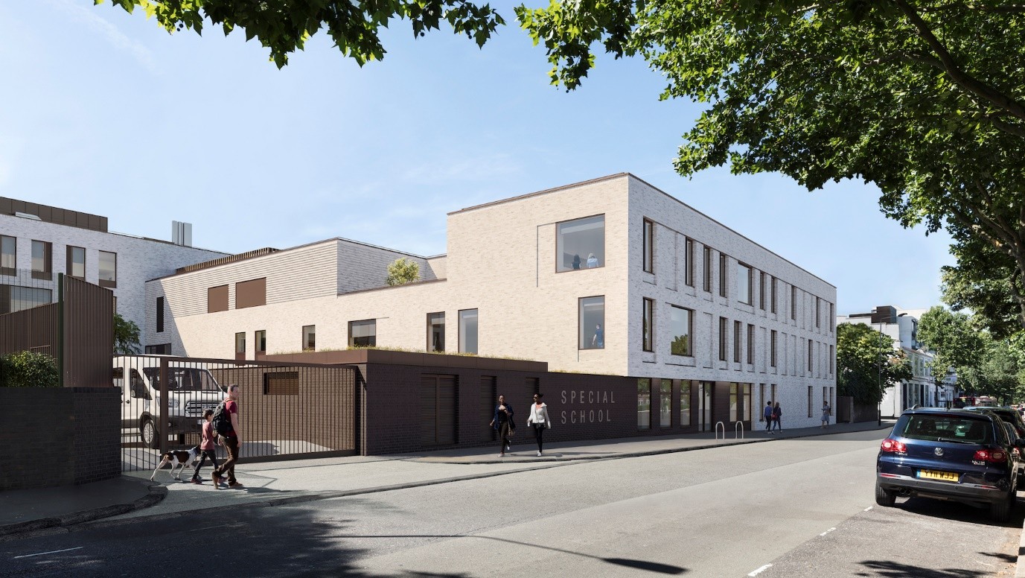

Introduction
Queen Charlotte Education Special Trust (QCEST) was formed in 2020 by Queensmill School, an Outstanding Special School in the London Borough of Hammersmith and Fulham. Queensmill School provides a renowned education for children with Autism Spectrum Condition (ASC), from the London Borough of Hammersmith and Fulham, the Royal Borough of Kensington and Chelsea, amongst others.
QCEST has been approved by the Department of Education to enter the ‘pre-opening’ phase for Kensington Queensmill School, on Barlby Road W10 6BH. opened, Kensington Queensmill will meet the needs of children and young people aged 2-19 years, who have ASC or Severe Learning Difficulties (SLD). When full, the school will provide provision for a total of up to 80 pupils. All pupils at the school will have special educational needs and/or disabilities (SEND) and an Education Health and Care Plan (EHCP).
At the Queen Charlotte Education Special Trust, we work collaboratively to improve the educational outcomes of all pupils with complex SEND needs, and to ensure all pupils reach their full potential. Our trust focuses on autistic spectrum conditions, severe learning difficulties, and social, emotional and mental health challenges. Our shared commitment as a trust will be to ensure that child/young person-centred learning is placed at the heart of all that we do.
Thank you,
Kensington Queensmill Team

Our Vision
QCEST focuses on children with autistic spectrum disorders; severe learning difficulties; or social emotional mental health challenges, across a cluster of appropriate settings. Throughout both settings – Queensmill and Kensington Queensmill – will be an approach to special educational needs within a common framework of policies, resources, governance and commitment to excellence, adapted as necessary to particular settings.
We will support schools joining our Trust by:
- Sharing specialist knowledge and best practice at all levels: including support and mentoring for school leaders and staff, developing future leaders and sharing specialist knowledge.
- Sharing training and development opportunities.
- Sharing key policies and approaches to develop our shared aspirations to provide outstanding education within the special education sector.
- Sharing central services to ensure that staff in schools can focus directly on their pupils.
- Providing planning, monitoring and evaluation systems to support our key aim that all pupils will make good or outstanding progress.
- Supporting local governing bodies.
- Sharing our commitment to academic research to ensure developing good practice.
Our shared commitment as a Trust will be to ensure that child/young person-centred learning is placed at the heart of all that we do.
We will build on the mission statement of Queensmill School:
‘A caring environment, where we respect and value children for who they are, help them understand the world around them and teach them to manage their autistic behaviours.’ (Queensmill Mission Statement)
In continuing this collective ethos, Kensington Queensmill will ensure that:
- Each pupil will be accepted and valued for who they are and what they can do. From this starting point we will help each pupil to make outstanding progress in acquiring academic, communication and social skills. All pupils will have personalised learning programmes so that they are motivated and thoroughly supported to make this progress.
- All staff are highly qualified and motivated; and have access to high quality CPD and training programmes.
- We work with parents and carers to understand and support their children’s learning, and to work closely with other concerned professionals to ensure that the particular needs of each pupil are met.
- We participate in research and maintain and develop our links with educational partners to ensure that our practice continues to be developed and enhanced. These partners include Universities, and our resource bases at Fulham Primary School (30 Places), Fulham College Boys (28 places), Fulham Cross Girls (12).

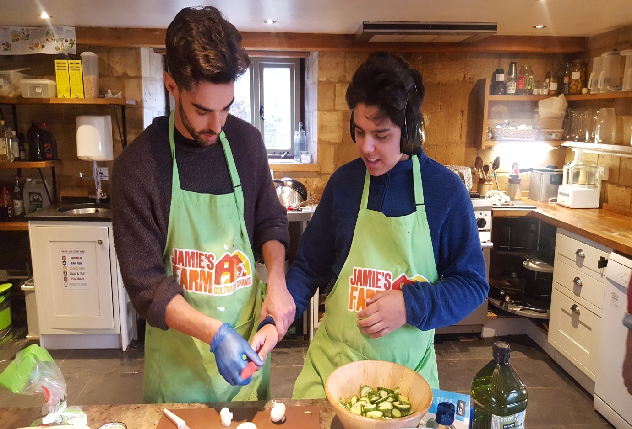

- Our Ethos
The key values that Kensington Queensmill will aim to uphold are as follows:
- Inclusion – Promote learning that is child-centred, with an emphasis on accepting people for who they are and providing unique programmes to suit their needs and interests
- Empowerment – Create learning systems that are structured to help pupils understand and cope with the world around them; provide training and empower staff to work successfully with CYP with autism
- Support – Ensure that all pupils reach their full potential through personalised support in academic and personal development, making sure that every pupil feels safe and able to express themselves
- Empathy and Compassion – Nurture the whole child and create a culture of empathy and compassion, so that our pupils develop these values
- Collaboration – Ensure that teachers, teaching assistants, occupational therapists, speech and language therapists and senior leaders: work collaboratively and constructively; work with parents/carers and carers to understand and support their child; build relationships with other Kensington and Chelsea schools; collaborate with other QCEST schools; work with other local organisations and professionals to share expertise and ensure a holistic approach to pupils’ welfare; and participate in research to draw from the very best of the practice and resources
- Community Engagement – Listen to all stakeholders, making sure that everything possible is done to support the local community and support CYP attending Kensington Queensmill to become valued and contributing members of their local communities.

- Curriculum and Delivery of Learning
At Kensington Queensmill, we will offer a welcoming and inclusive learning environment in which vulnerable pupils are valued, cherished and nurtured, and in which personalised learning approaches contribute powerfully to supporting pupil achievement and personal development.
Our vision focuses on enabling CYP to progress in both academic and social skills. Inclusion is at the core of our ethos and values, and our approach will value diversity as a rich resource. Our provision at Kensington Queensmill will recognise “a child’s right to a broad, balanced, relevant and challenging curriculum which is appropriate to their individual abilities, talents and personal qualities” (Inclusion Quality Mark, Queensmill, 2017). Our staff will work to remove barriers to learning and participation and they will strive to transform what are understood to be deficits into strengths.
Pupils at Kensington Queensmill will have a diagnosis of an Autistic Spectrum Disorder (ASC) or of Severe Learning Difficulties (SLD), and everything that we do in school will take account of these needs. All staff will be trained in ASC and SLD, and will take a personalised approach that will lead to the highest possible learning outcomes for each of our pupils. Lesson planning, for example, will take into consideration pupils’ special interests to facilitate high levels of engagement.
We will deliver a rich and varied curriculum. Wherever possible, the content will have a functional purpose and be engaging and relevant. There will be discrete core curriculum time, focused on the EYFS, National Curriculum or Preparing for Adulthood (PFA) framework, coupled with teaching and learning designed to develop pupils’ understanding and knowledge of the world around them and their social communication and emotional regulation skills.
The intention with Kensington Queensmill would be to replicate the outreach model in place at Queensmill School, with the Kensington Queensmill acting as a hub of autism knowledge, resource and practice across Kensington and Chelsea. This can be achieved through promoting an agenda of school empowerment and training, using the expertise at the Kensington Queensmill to provide a programme of creating autism ‘champions’ in individual schools to ensure that the quality of autism practice in individual settings is of the highest quality.
The Kensington Queensmill will be able to build upon the existing relationships the Queensmill service has with Kensington and Chelsea schools including: Fox Primary, Cardinal Vaughan, Chelsea Academy, Bousfield Primary, St Thomas CE, St Francis of Assisi, Sion Manning, Holland Park, Christ Church, Coleville Primary, St Charles RC. Additionally, it will be able to continue the long-standing relationship between Queensmill and the autism-resource bases in Kensington and Chelsea: The Orchard at Barlby Primary, Marlborough Primary and Kensington Aldridge Academy.
The school will have close links with a number of local organisations that offer support to CYP on the autism spectrum and their families. The Deputy Safeguarding Lead will have the role of social services link and will work collaboratively with the social workers within the Disabled Children’s Team, Looked After Children and Virtual Schools Team as well as Early Help services to ensure that children, young people and their families receive appropriate and effective support that takes into consideration the pupils’ individual needs linked to their Autism/SLD. As mentioned above, CYP attending Kensington Queensmill will have secure access to the facilities and expertise of Q House, Queensmill’s registered Children’s Home. Furthermore, the school will also have a Family Support Worker, who will work with families on a ‘Child In Need’ or ‘Child Protection’ plan who may require additional training or support in understanding and managing their child’s autism or transferring strategies from school to the home setting.
Kensington Queensmill will also ensure effective working partnerships with parents/carers for two principle reasons: to ensure the development and progression of CYP is being realised and achieved across all contexts and to guarantee that parents/carers feel they are a valuable and considered part of their CYP’s educational experience. Kensington Queensmill will be able to draw upon the expertise and experience of staff at Queensmill, particularly the school’s family support worker, who already supports Kensington and Chelsea families with autistic CYP. This can be achieved through various means ranging from the provision of a high-quality and consistently used home-school book to inviting parents/carers to be integral architects in their CYP’s education.
Finally, the other QCEST school, Queensmill, has a number of long standing partnerships with: the University College London and Institute of Education; the Centre for Research into Autism Education; an E-mentors project with UCL/IOE; St Mary’s University and the School’s Direct Programme; the University of Roehampton; Georgia College; and the Erasmus Exchange Programme. Kensington Queensmill can also look to benefit from collaborating with such institutions on research and development.

- Referrals
Kensington Queensmill will be located at Barlby Road, North Kensington, London, W10 6BH. It will meet the needs of children and young people aged 2-19 years, who have autistic spectrum disorders (ASC) or severe learning difficulties (SLD). When full, the school will provide provision for a total of up to 80 pupils. All pupils at the school will have special educational needs and/or disabilities (SEND) and an Education Health and Care Plan (EHCP).
Kensington Queensmill school will work closely with Local Authority SEN departments, to ensure that children and young people admitted to the school are within the school’s criteria. These are:
- A Statement of Special Educational Need (SEN) or an Education, Health and Care Plan (EHCP)
- Working at academic levels well below age-related expectations. Whilst children in mainstream primary settings would be achieving up to level 2 at KS1 and up to level 5 at KS2, the children in Kensington Queensmill are likely to achieve well below age-related expectations and being assessed according to the engagement model.
All decisions on placement will involve both an assessment of consultation papers and an observation visit of the child in person.
In order to help the child in their move to Kensington Queensmill, we put a transition plan in place, working with the child’s parents and, where they are coming from a school, with their present school. This would involve visits, social stories, photos books, etc; we would be led by the child in this, but would put in place everything possible to help them move easily into their new school.
We have a very good track record in this. We have admitted children directly after diagnosis and as young as two, as well as children in any year group in the school. We have considerable experience admitting children and young people of all ages, who will have come from other schools or from home education. We are proud to say that we have always made the transition smooth for both the child and their parents/carers. We conduct an initial baseline assessment (i.e. after two weeks) and then another comparative baseline after 6-8 weeks, meet with parents as part of this process and agree longer term academic and social targets – which will inform the EHCP and other assessed targets for learning.
- Frequently Asked Questions
What is a free school?
Free schools are independent, state-funded schools with the same legal status as academies.

Will the school be able to make a profit?
No. The school will be run on a not-for-profit basis by Queen Charlotte Education Special Trust. The school will be run by the Headteacher and their leadership team and they will be answerable to a Board of Governors.

What does it mean to enter into a Funding Agreement with the Secretary of State for Education?
When an academy enters into a Funding Agreement, they effectively enter into a contract between themselves and the Secretary of State for Education. This contract, or Funding Agreement, is how academies are held accountable to the Department for Education.

Will funding the school mean there will be less money for the other special and mainstream provision in the area?
No. Funding for Kensington Queensmill will be worked out equivalent to the funding available to other special schools in the area and it will not reduce the overall funding available for schools in RBKC.

Will the Kensington Queensmill be inspected by Ofsted?
Yes. The school will be subject to inspection in the same way as other schools. All new schools are also inspected by Ofsted prior to the school opening and receives ongoing scrutiny from DfE.

Have you chosen a Headteacher for the Kensington Queensmill?
This processing is ongoing. There will be an open and fair competition to recruit an exceptional candidate to lead the school. Prospective pupils and their parents/carers will have the opportunity to meet the Headteacher Designate at community events once they have taken up post.

How will the school be accountable?
The school will be run by a Local Governing Body who will be accountable to the Trustees of the Queen Charlotte Education Special Trust. In addition, the school will be accountable to the Secretary of State for Education through the terms of its Funding Agreement. The school will, of course, be accountable day to day to parents/carers and the wider community.

How will you engage with Kensington and Chelsea local schools and headteachers?
Our schools deliver practice models that not only tailor education to students, but also involve local schools, parents, carers and agencies, forming a network of support for all of our young people. Queen Charlotte Education Special Trust is committed to build from community engagement and provide a provision tailored for the children and their needs. We are planning to cooperate with other local headteachers through the pre-opening phase and keep a close relationship with local schools after opening.

How would students be referred to the provision? How will costing and funding work?
The referrals policy is still being finalised. It is anticipated that places will be filled by pupils with EHCPs, and who named the new school in their EHCP. Both the Royal Borough of Kensington and Chelsea and surrounding boroughs will have the possibility to commission places at the School.
We are actively soliciting feedback from local schools and will feed this into our discussions with the local authority.

What will the curriculum look like?
This will be developed from the curriculum which we deliver in our Queensmill school, using our experience to provide for those with the most complex needs.
Queen Charlotte Education Special Trust is fully aware there are no one-size-fits-all provision. We aspire to bring our expertise and shape it with the particular needs of the local community of Kensington and Chelsea. The school will tailor a broad and balanced curriculum rooted in community learning where children experience and internalise the positive values of a healthy learning community.
The strength of our curriculum is its flexibility, which will allow us to create a programme designed and tailored for the children according to their specific needs. Our school will include specialist staff that will be working closely will the pupils and make sure that no pupils is left behind.
To ensure successful reintegration where appropriate, the new school will work very closely with mainstream schools as well as special schools in the locality and design and implement a curriculum aligned to mainstream education as much as possible, so that our pupils are not disadvantaged when they re-enter mainstream settings.
We are including the feedback from local headteachers to build on a fit and tailored curriculum so we can provide the best for our pupils.

COVID19
The trust is committed to maintaining its commitment to its pupils throughout the pandemic. Our pupils are among the most vulnerable in the country, and their wellbeing, as that of our staff, remains our priority. We will continue to adapt as the situation evolves, and will continue to strictly adhere to government guidelines.

